Passive Open-Source Reconnaissance
Report

Target: Safaricom PLC | Publicly Available Information Review Assessment Date: 24 October 2026 Scope Notice: Prepared for educational OSINT assessment. No active security testing was performed.
1. Executive Summary
This report documents a passive open-source intelligence (OSINT) review of publicly available assets associated with Safaricom PLC. The primary objectives were to document observable hostname footprint data, review public M-PESA/Daraja integration patterns, analyze official API documentation, and clarify official vulnerability reporting pathways.
Sources evaluated during this assessment include Certificate Transparency (CT) logs,
DNSDumpster records, public GitHub repositories, Safaricom’s official Daraja developer documentation, and the Safaricom HackerOne directory listing. These sources provide informational insights into external asset visibility and developer resources. No security vulnerabilities, leaked production credentials, or employee-related security weaknesses were verified or exploited during this assessment.
Important Data Limitation: As observed in collection evidence, Certificate Transparency search outputs from crt.sh explicitly indicate result set truncation. Consequently, a definitive or deduplicated total inventory of all subdomains cannot be established solely from the supplied point-in-time evidence.

2. Target, Scope, and Responsible Disclosure
● Organization: Safaricom PLC
● Primary Domain Reviewed: safaricom.co.ke
● Secondary Domain Reviewed: safaricom.com (as listed in HackerOne directory
metadata)
● Assessment Methodology: Strictly Passive OSINT Review
● Official Disclosure Policy URL: https://hackerone.com/safaricom?type=team
Responsible Disclosure & Scope Analysis
Safaricom’s public HackerOne directory listing lists safaricom.co.ke and safaricom.com as primary assets and designates bugbounty@safaricom.co.ke as the primary security reporting contact. The program terms state that valid, high-impact security submissions may qualify researchers for an invitation to Safaricom's private Bug Bounty Program.
Key policy rules noted during scoping:
1. Research must remain restricted strictly to qualifying, authorized assets.
2. Third-party hosting environments, integrated vendor infrastructure, and unauthorized
subdomains are explicitly out of scope.
3. Public disclosure of vulnerability details without authorization is prohibited.
4. The directory listing does not grant blanket authorization for active or intrusive testing
against all resolved hostnames.
This assessment strictly complied with these terms by using non-intrusive public data collection methods (web searches, public repositories, and DNS/CT log index lookups). No login forms, endpoints, or network services were interacted with or tested.
3. Methodology and OSINT Source Classes
The passive reconnaissance methodology utilized five distinct classes of open-source
intelligence. The table below outlines each source class, the observed materials, and their strategic relevance to defensive operations:
OSINT Source Class
1. Certificate Transparency
(CT)
Observed Materials & Tools
crt.sh log query (%.safaricom.co.ke) yielding TLS/SSL certificate issuance entries.
Defensive Relevance & Asset
External Attack Surface Management: Enables defenders to track active/legacy hostnames, audit certificate lifecycle management, and identify undocumented subdomains.
2. Passive DNS & Host
Discovery
Observed Materials & Tools
DNSDumpster query results showing A records, IP mappings, and CDN associations.
Defensive Relevance & Asset
Asset Mapping & Proxy Identification: Helps defenders reconcile DNS records against internal inventories, identifying third-party cloud routing (e.g.,Imperva/Incapsula).
3. Code Repository Search
Observed Materials & Tools
Public GitHub repositories (e.g.,safaricom-daraja-api-stk-push-python,
Defensive Relevance & Asset
Developer Exposure & Secret Scanning: Assists defensive teams in auditing public code Visibility mpesa-payment-service). for hardcoded API keys, insecure implementation examples, or leaked environment configs.
4. Official Developer Portals
Observed Materials & Tools
Safaricom Daraja Developer Portal (developer.safaricom.co.ke) and M-Pesa Express Simulate endpoints.
Defensive Relevance & Asset
Integration Baseline & Architecture: Provides defenders and integrators with authorized API specs, verifying strict boundary isolation between sandbox and production environments.
5. Vulnerability Disclosure Data
Observed Materials & Tools
Safaricom HackerOne directory listing ([hackerone.com/safaricom](https://hackerone.com/safaricom)).
Defensive Relevance & Asset
Governance & Escalation: Establishes clear reporting protocols and scope boundaries for security researchers and internal incident response teams.
4. Hostname Inventory & Subdomain Observations
Observed Hostname Sample (13 Representative Examples)
From the DNS and Certificate Transparency dataset, the following representative hostnames under safaricom.co.ke were cataloged:
● accounts.safaricom.co.ke
● beta.accounts.safaricom.co.ke
● api.safaricom.co.ke
● secure.api.safaricom.co.ke
● api2.safaricom.co.ke
● apistg.safaricom.co.ke
● apps.safaricom.co.ke
● partnerhub.safaricom.co.ke
● selfcare.safaricom.co.ke
● webchat.safaricom.co.ke
● api.county.safaricom.co.ke
● tesinvoices.safaricom.co.ke
● mocha.safaricom.co.ke
Dataset Count & Limitations
● Sample Count: 13 key functional hostnames explicitly recorded from evidence screens.
● Truncation Warning: CT log search output via crt.sh explicitly displays a warning: "Sorry,
your search results have been truncated. ... only a random subset is shown."
● Analytical Conclusion: Due to log truncation and historical DNS caching, a definitive
total count of unique subdomains cannot be established from this evidence.
● Infrastructure Association: Passive DNS records indicate multiple endpoints route
through Imperva/Incapsula Web Application Firewall (WAF) infrastructure. This
observation reflects edge proxy routing and does not imply specific internal architecture or security status.
5. Findings & Defensive Impact Analysis
Finding 1: Observable External Subdomain Footprint
● Classification: Informational / External Asset Visibility
● Observed Evidence: crt.sh and DNSDumpster queries reveal functional subdomains
spanning customer authentication (accounts.), API routing (api., apistg.), partner portals
(partnerhub.), and invoice management (tesinvoices.).
● Defensive Significance & Impact:
○ Unmonitored or legacy subdomains (e.g., staging or beta instances like apistg. or
beta.accounts.) can become shadow IT risks if left unpatched or unmonitored.
○ Comprehensive DNS tracking ensures that retired services do not leave orphaned
CNAME entries that could lead to subdomain takeover risks.
● Remediation & Defense Recommendation:
○ Reconcile passive DNS/CT log entries against the organization’s master asset
inventory.
○ Implement automated Certificate Transparency log monitoring to detect
unauthorized or accidental certificate issuances in real time.
○ Decommission legacy DNS records for obsolete staging endpoints.
Limitations: Records do not prove that every hostname is active, externally reachable, owned exclusively by Safaricom, or vulnerable. No active checks were performed and no complete hostname count was established.
Finding 2: Third-Party M-PESA Integration Code Repositories
● Classification: Informational / Public Code Audit
● Observed Evidence: GitHub repositories (e.g.,
stangatimu/safaricom-daraja-api-stk-push-python and munuhee/mpesa-payment-service)
contain sample Flask/Python code illustrating Lipa na M-PESA Express integrations.
● Defensive Significance & Impact:
○ Third-party community integration tutorials frequently demonstrate implementation
mechanics for API calls (STK Push).
○ If developers inadvertently copy sample code containing hardcoded credentials into
production repositories, authorization tokens or passkeys could be exposed to
automated scanners.
○ Note: Review of these public sample repositories confirmed no valid Safaricom
corporate secrets or production credentials were present.
● Remediation & Defense Recommendation:
○ Enforce automated secret-scanning tools (e.g., GitGuardian, GitHub Secret
Scanning) across all internal and public developer repositories.
○ Require the use of environment variables or secret vaults (e.g., HashiCorp Vault,
AWS Secrets Manager) for all Daraja API consumer keys and secrets.
○ Publish official SDKs and implementation guidelines to minimize reliance on
unverified community code snippets.
Limitations: The repositories appear independently maintained; their existence does not establish Safaricom ownership, endorsement, deployment, or a vulnerability in Safaricom systems. No credentials were tested or verified.
Finding 3: Public API Documentation & Defined Reporting Route
● Classification: Informational / API Isolation & Vulnerability Management
● Observed Evidence: The official Daraja portal (developer.safaricom.co.ke) documents
M-Pesa Express simulation endpoints (e.g.,
[https://sandbox.safaricom.co.ke/](https://sandbox.safaricom.co.ke/)...). Concurrently, the
HackerOne directory entry details official vulnerability reporting routes
(bugbounty@safaricom.co.ke).
● Defensive Significance & Impact:
○ Clear separation between developer sandbox hostnames
(sandbox.safaricom.co.ke) and production payment environments prevents
accidental test transaction leakage into live ledgers.
○ Operating a transparent vulnerability reporting process ensures external security
researchers can report potential findings responsibly rather than disclosing them
publicly.
● Remediation & Defense Recommendation:
○ Maintain strict IP restriction and credential isolation between sandbox environments
and production payment gateways.
○ Continuously monitor and respond to submissions sent to
bugbounty@safaricom.co.ke in accordance with defined SLAs.
Limitations: Documentation and directory screenshots do not demonstrate a weakness or authorize testing of every hostname or third-party system.
6. Employee Enumeration & Credential Handling
● Employee Privacy & Risk Assessment: No individual employee names, email
addresses, or social media profiles were compiled or evaluated for security findings.
OSINT best practices dictate that personal employee details should not be targeted
without specific authorization.
● Credential Verification Notice: No leaked corporate credentials, database dumps, or
active authorization tokens were verified or tested during this assessment.
● Handling Procedures for Discovered Secrets: Should any future passive review
uncover potential credentials or API keys in public repositories, the following protocol
must be strictly observed:
1. Do NOT attempt to authenticate or test the credential against any system or API
endpoint.
2. Record only the minimal necessary reference metadata (URL, file path, commit
hash, date).
3. Redact all secret values in documentation.
4. Immediately report the item confidentially via bugbounty@safaricom.co.ke.
7. Activities Not Performed (Passive Boundaries & Limitations)
To remain strictly non-intrusive and adhere to legal, ethical, and scope boundaries, the following
active security assessment activities were explicitly excluded:
1. Active Scanning & Enumeration: No port scanning (e.g., Nmap), active sub-domain
brute-forcing (e.g., Amass, Gobuster), or web application vulnerability scanning (e.g.,
Burp Suite, OWASP ZAP) was conducted.
2. Service Interrogation: No HTTP header probing, administrative portal discovery, or
directory traversal tests were performed.
3. Authentication & Session Testing: No attempts were made to log into identified
customer portals (accounts.safaricom.co.ke), partner hubs, or administrative interfaces.
4. API Interactivity: No live test transactions, STK Push requests, or payload submissions
were sent to sandbox or production API endpoints.
5. Social Engineering & Phishing: No communications, phishing simulations, or social
engineering tactics were directed at Safaricom staff or partners.
Why These Boundaries Matter: Active testing without explicit written authorization or active
bug bounty scope inclusion can cause service disruption, trigger false positive alerts for security
operations teams, or violate computer misuse legislation. Passive OSINT provides valuable
defensive visibility while maintaining zero operational risk to target environments.
8. Evidence Register and References
DISC-01 — Safaricom HackerOne directory listing: https://hackerone.com/safaricom?type=team
CT-01 — crt.sh search for %.safaricom.co.ke: https://crt.sh/?q=%25.safaricom.co.ke
DNS-01 — DNSDumpster: https://dnsdumpster.com/
GH-01 — Python/Flask Daraja STK Push example: https://github.com/stangatimu/safaricom-daraja-api-stk-push-python
GH-02 — M-PESA payment-service example: https://github.com/munuhee/mpesa-payment-service
API-01 — Official Daraja M-Pesa Express Simulate documentation: https://developer.safaricom.co.ke/apis/MpesaExpressSimulate
API-02 — Official Daraja developer portal: https://developer.safaricom.co.ke/apis

9. Conclusion
This passive reconnaissance assessment successfully cataloged observable hostname data, public integration tutorials, official API documentation structures, and vulnerability reporting procedures for Safaricom PLC. All findings are informational and provide actionable insights for defensive asset tracking, credential management, and external attack surface management. No vulnerability claims were asserted, no truncated log sets were misrepresented, and strict adherence to non-intrusive testing principles was maintained throughout.

Appendix A — Evidence Screenshots
Screenshots retained from the supplied report. Captions describe the limited observation supported by each image.
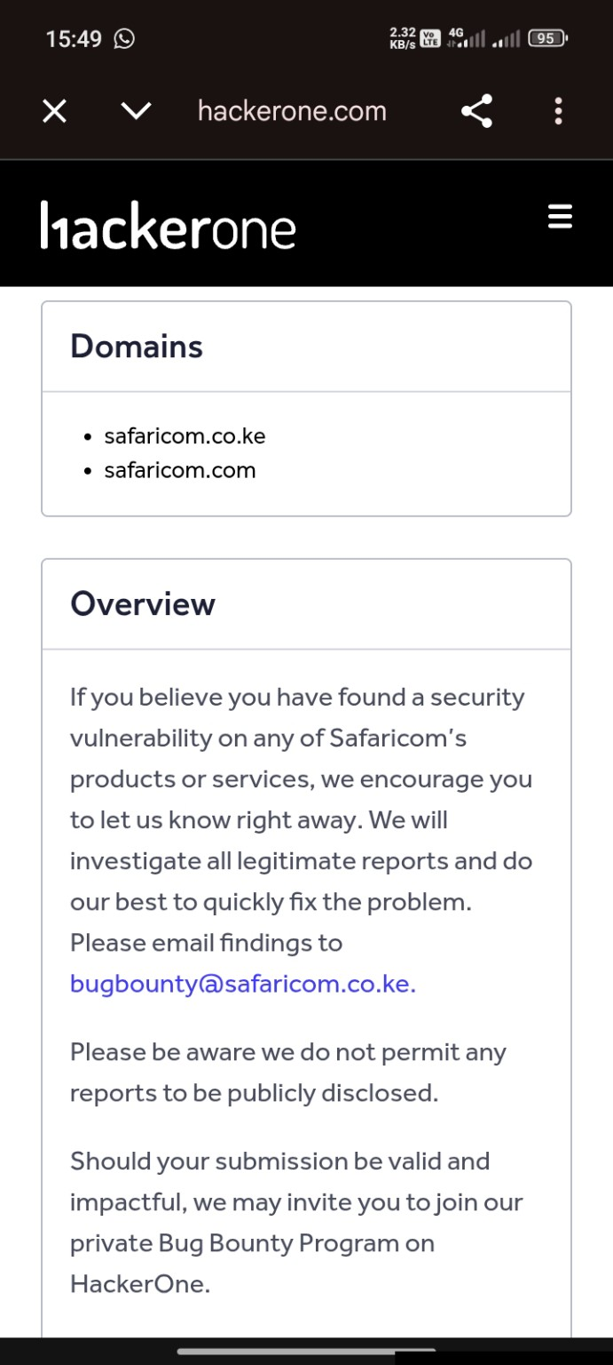
Figure A1. Evidence screenshot
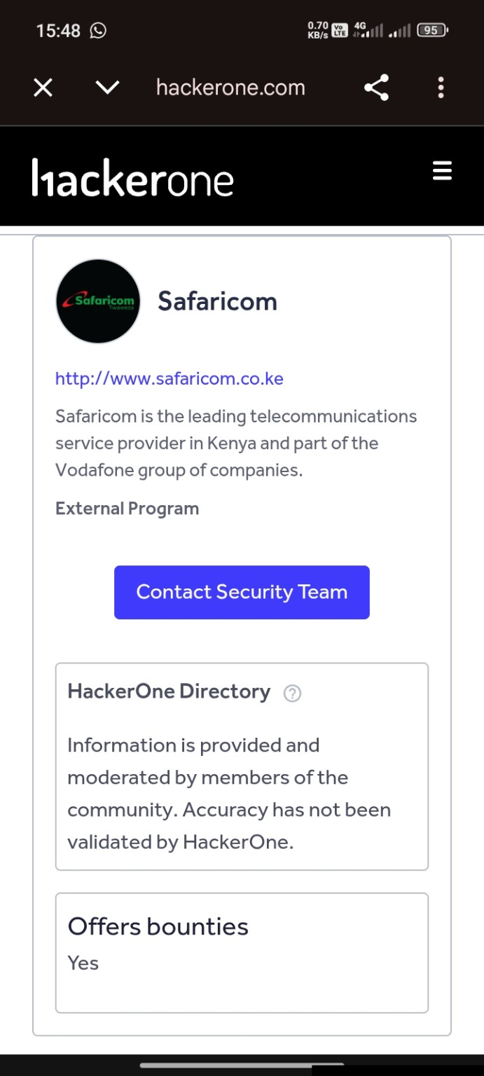
Figure A2. Evidence screenshot retained from the original report.
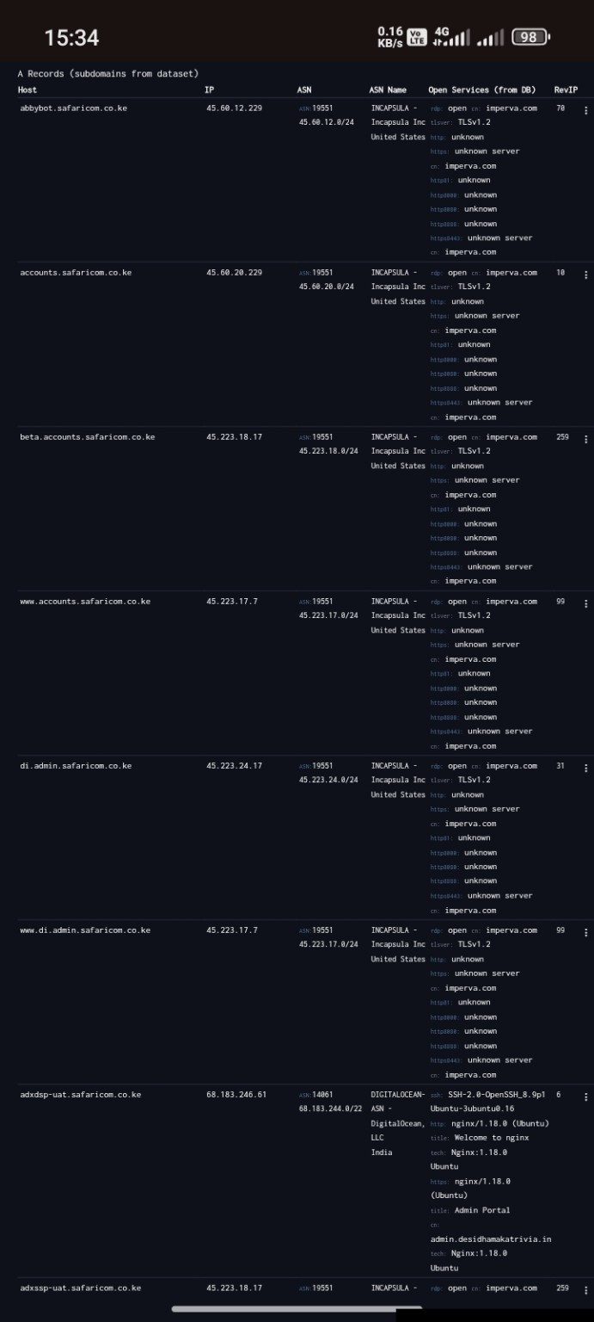
Figure A3. Evidence screenshot retained from the original report.
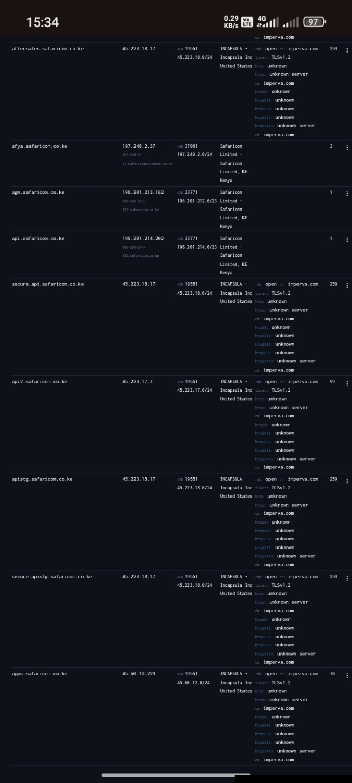
Figure A4. Evidence screenshot retained from the original report.
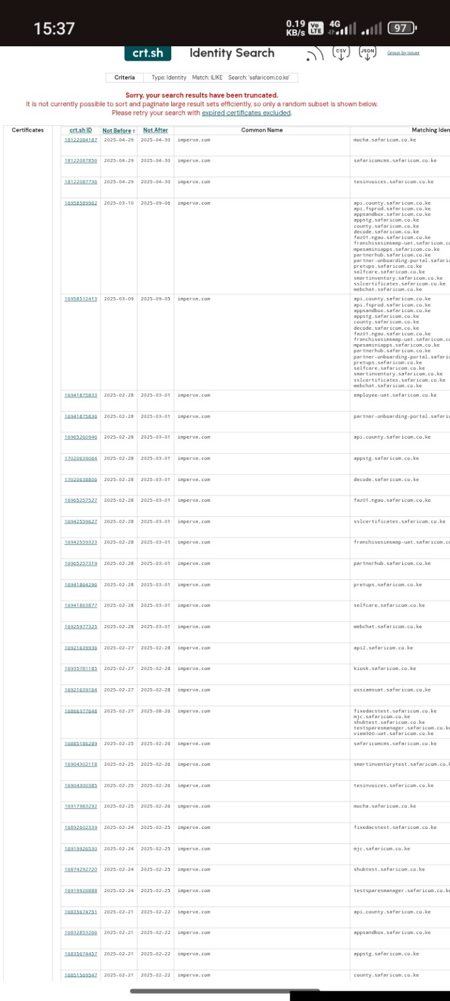
Figure A5. Evidence screenshot retained from the original report.
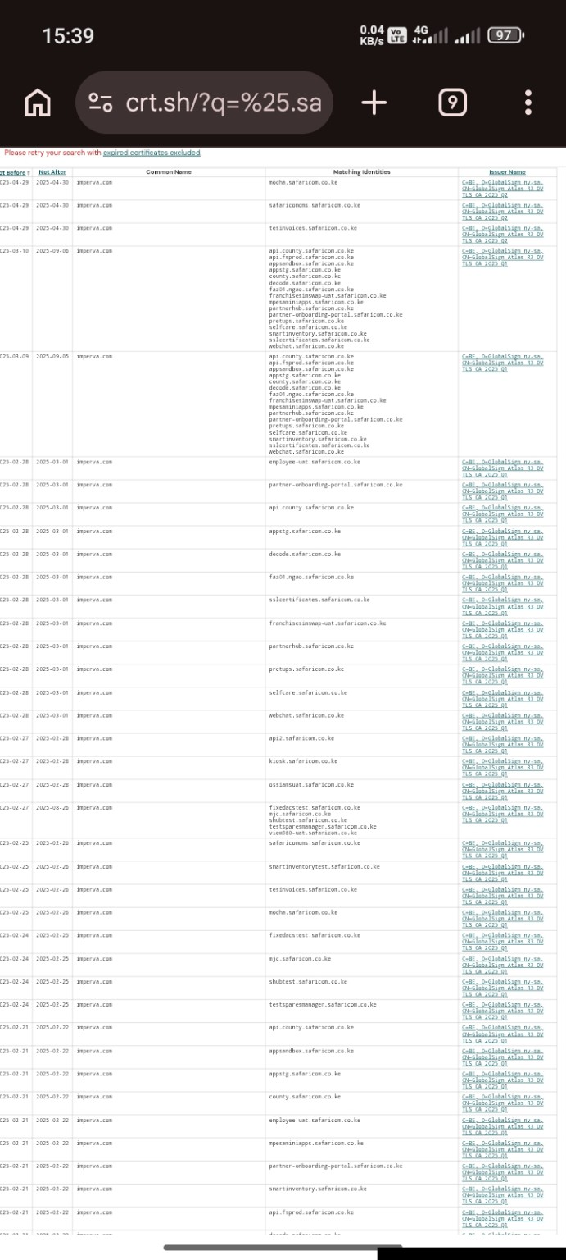
Figure A6. Evidence screenshot retained from the original report.
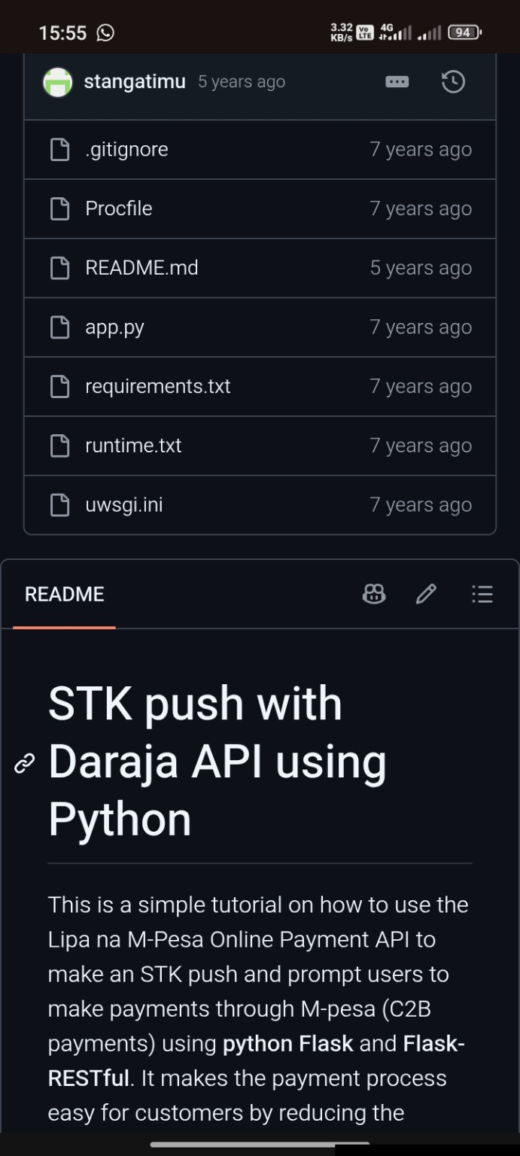
Figure A7. Evidence screenshot retained from the original report.
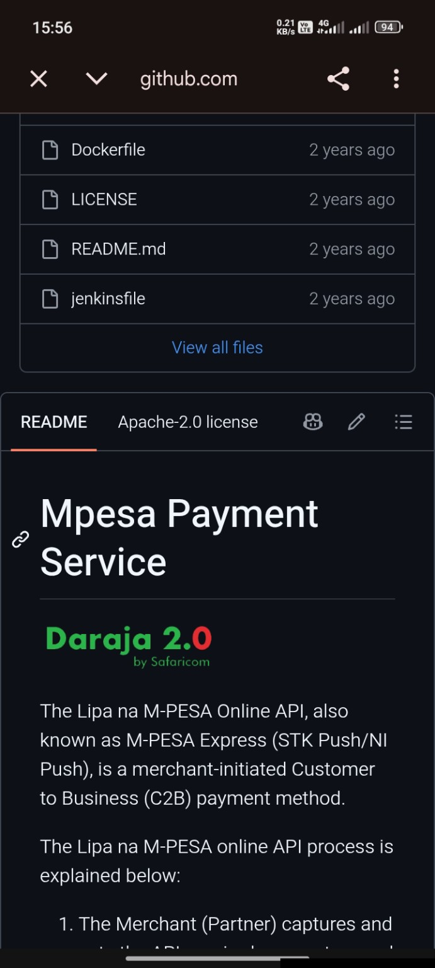
Figure A8. Evidence screenshot retained from the original report.
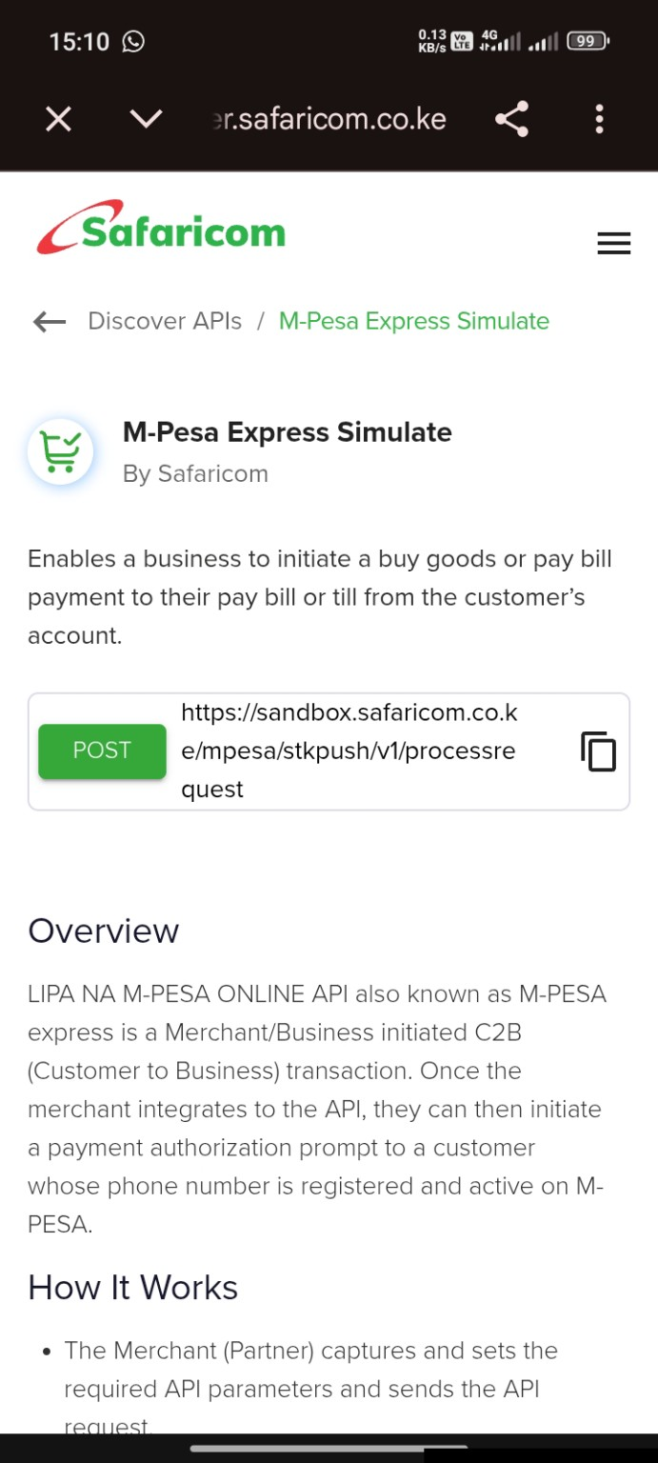
Figure A9. Evidence screenshot retained from the original report.

